SATELLITE NEWS (Summer Edition)
Week of July 11-14, 2022 Volume 1, Issue 5
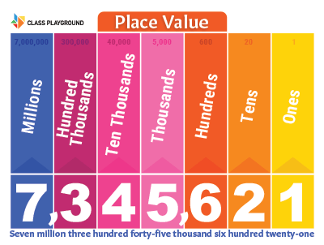  FRIENDLY REMINDERS  Our culminating fieldtrip is on Monday, July 18, 2022. Please ensure your child is at school no later than 7:45 a.m. on this day. We will be leaving the school by 8:15 a.m. Parents who are interested in joining us, you may purchase your tickets for the movie at the Micronesia Mall Stadium Theatres Box Office. Children ages 3-11 are $7.00 and adults are $8.50. PLEASE NOTE: We will NOT be able to give you a refund if your child is unable to attend due to a flat rate provided to our group.  WEEK 6 (July 18-20, 2022):  Movie Fieldtrip – Monday, July 18, 2022  Showcase Day – Tuesday, July 19, 2022  11:00 – 11:45 a.m. (Parents/Guardians)  End-of-Summer Bash Party – Wednesday, July 20, 2022 (Classroom parties) LAST DAY OF SUMMER SCHOOL  ANNOUNCEMENTS  ★GDOE Summer Fair  The GDOE Summer Fair will be held this Saturday, July 16, 2022 from 10:00 a.m. to 2:00 p.m. at the Agana Shopping Center. We will be highlighting the wonderful projects our students have completed during the duration of the program. If you have time, please stop by to show your support.  ★Showcase Day, Tuesday, July 19, 2022  Parents and guardians are invited to see the projects students have been working on during the duration of the program. Classroom visits will be from 11:00-11:45 a.m. You may sign out your child with his or her respective teachers after visiting the classrooms on this day.  CONTACT  Should you have any questions or concerns, please do not hesitate to contact the Summer School Coordinator, Mrs. Ann Marie Trusso, at (671) 300-2932.  FUNDING DISCLOSURE This activity is administered by the Guam Department of Education (GDOE) – Federal Programs Division/Grants Office and funded by the U.S. Department of Education – Consolidated Grant to the Outlying Areas, the Education Stabilization Fund – State Education Agency (ESF-SEA), and the Education Stabilization Fund II – State Educational Agency (ESF II – SEA) | Every Place Has a Value  This week teachers concentrated their lessons on “place value.” Place value is the value of each digit that appears in a number. Understanding place value helps you to work out the value of a number. For example, in the number 627, the 6 is 600 (hundred), the 2 is 20 (tens) and the 7 is 7 (units, or ones in other words). To make this clearer to children, teachers like to represent this in the form of place value columns, where the constituent numbers are placed according to whether they’re 100s, 10s or 1s and so on.  This week we are featuring our 3rd, 4th and 5th graders with their latest projects.  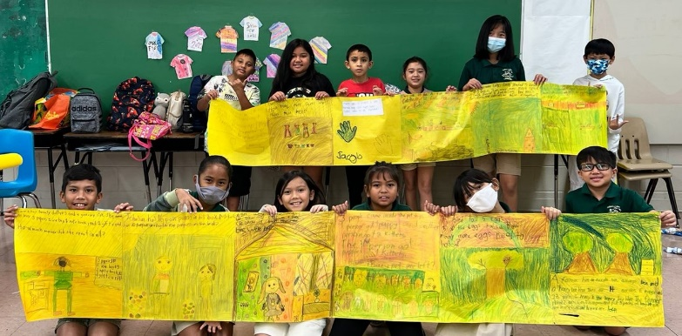  3rd Grade  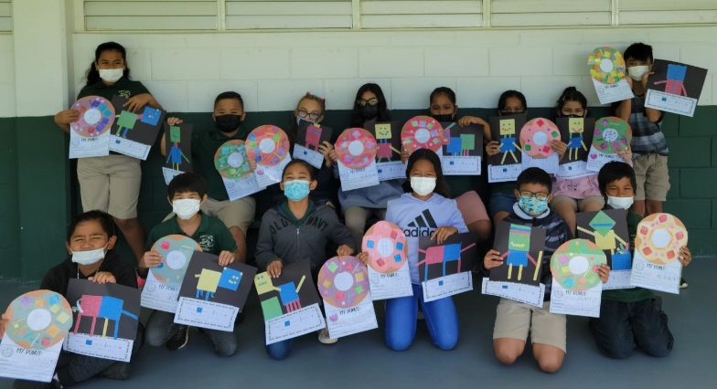  4th Grade  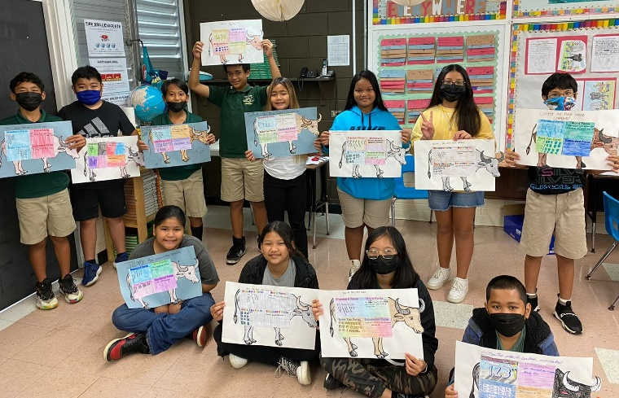  5th Grade
P.C. Lujan Elementary School 387 E. Route 8, Barrigada, Guam 96913 Tel. (671-734-3971)
Beth N. Perez, Acting Principal

