SATELLITE NEWS (Summer Edition)
Week of June 27-30, 2022 Volume 1, Issue 3
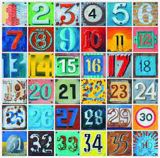  FRIENDLY REMINDERS  If your child is not feeling well, please keep him or her home to avoid contact with others. Please provide an excuse note when they return to the program.  NO CLASSES ON MONDAY, JULY 4, 2022 (INDEPENDENCE DAY HOLIDAY)  ANNOUNCEMENTS  ★ Fieldtrip Payment  We will begin receiving fieldtrip payments starting next week for the culminating activity on July 18, 2022 to the Micronesia Mall theatres. The cost will be $25 per child, which includes bussing, admission and food (hot dog, popcorn and a drink). You may give payment to your child’s teacher or Mrs. Trusso. Parents and guardians are welcomed to join us. If you are interested, please let your child’s teacher know. The last day for payment is JULY 11, 2022.  Special thanks to Peter and Trisha Aguon (Adam H.’s parents) for their generous donation to our upcoming fieldtrip to assist in the cost for bussing.  CONTACT  Should you have any questions or concerns, please do not hesitate to contact the Summer School Coordinator, Mrs. Ann Marie Trusso, at (671) 300-2932.  FUNDING DISCLOSURE This activity is administered by the Guam Department of Education (GDOE) – Federal Programs Division/Grants Office and funded by the U.S. Department of Education – Consolidated Grant to the Outlying Areas, the Education Stabilization Fund – State Education Agency (ESF-SEA), and the Education Stabilization Fund II – State Educational Agency (ESF II – SEA) | “Numbers, Numbers Here and There”  Can you believe we are halfway done with the Summer School Program? There are only two and a half more weeks to go! This past week we focused our lessons on numbers. Numbers are an integral part of our everyday lives. Most numbers are real numbers. They help us to count and to measure out quantities of different items. Real numbers exist in sports statistics and even the money in your wallet. Some other real life application of real numbers include; measurement in cooking, speed, weather, air temperature, wind speed and direction. Even when relaxing at the end of the day in front of the television flicking from one channel to the next you are using real numbers. Real numbers are everywhere!  This week we are featuring our fourth and fifth graders along with their number projects.  4th Grade  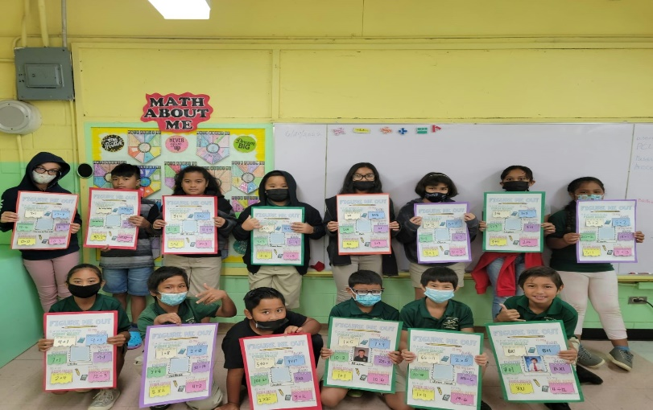  Ms. Taitague’s fourth graders showing their number projects.  5th Grade  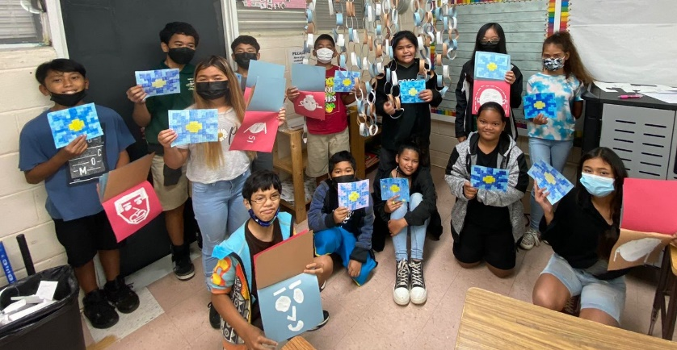  Ms. Sanz’s fifth grade students showing their number projects.
P.C. Lujan Elementary School 387 E. Route 8, Barrigada, Guam 96913 Tel. (671-734-3971)
Beth N. Perez, Acting Principal

