SATELLITE NEWS (Summer Edition)
Week of June 20-24, 2022 Volume 1, Issue 2
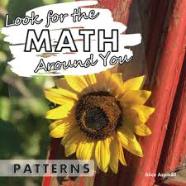  FRIENDLY REMINDERS  Summer School starts at 7:45 a.m. and ends at 12:00 p.m. Monday through Thursday. There are NO CLASSES ON FRIDAYS. Please ensure your child makes it to school on time. Late pickup is 12:15 p.m.  Please provide a snack for your child to consume during the morning recess break.  WEEK 3 (June 27-30, 2022):  NUMBERS, NUMBERS HERE AND THERE  SPIRIT MONDAY - Monday, June 27, 2022: Wear a number.  ANNOUNCEMENTS  ★ Satellite Bucks  We started implementing our “Satellite Bucks” incentive program with the students. Students can earn bucks by attending summer school daily, displaying good behavior, completing their work, as well as following school-wide rules. They will have the opportunity to cash out their bucks for a variety of incentives including free time in class, on the computer, snack time, and even socialize time. Students may opt to accumulate more bucks to cash out at the end of the program as well.  CONTACT  Should you have any questions or concerns, please do not hesitate to contact the Summer School Coordinator, Mrs. Ann Marie Trusso, at (671) 300-2932.  FUNDING DISCLOSURE This activity is administered by the Guam Department of Education (GDOE) – Federal Programs Division/Grants Office and funded by the U.S. Department of Education – Consolidated Grant to the Outlying Areas, the Education Stabilization Fund – State Education Agency (ESF-SEA), and the Education Stabilization Fund II – State Educational Agency (ESF II – SEA) | “Patterns, Patterns Everywhere”  This past week we focused our lessons on patterns. Patterns are important in real life. They provide a sense of order in what might otherwise appear chaotic. Researchers have found that understanding and being able to identify recurring patterns allow us to make educated guesses, assumptions, and hypothesis; as well as help us develop important skills of critical thinking and logic. Logic, number, and word patterns are all around us! Logic patterns help us classify similar objects, while number patterns help us predict a sequence. Word patterns help children make sense of language and serve as a strategy for spelling. Repeating patterns can be found in nature and everyday life.  This week we are featuring our second and third graders along with their pattern projects.  2nd Grade  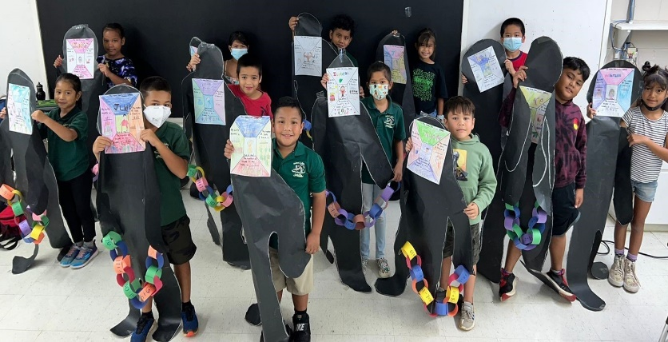  Ms. L. Lizama’s second graders showing their “Math About Me” and pattern projects.  3rd Grade  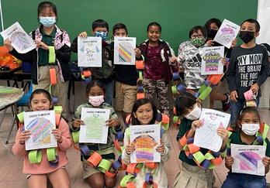  Ms. K. Lizama’s third grade students showing their pattern design projects.
P.C. Lujan Elementary School 387 E. Route 8, Barrigada, Guam 96913 Tel. (671-734-3971)
Beth N. Perez, Acting Principal

